Q1. jenkins cicd :

url: https://github.com/devopsexamus/nodejsapp.git

1. **Cloned the url and checked the branch**
   1. We don’t have any access to create the git repo,no git hub access for the exam ..so as per the advice from the hr and team.. cloned the repo and done the cicd.

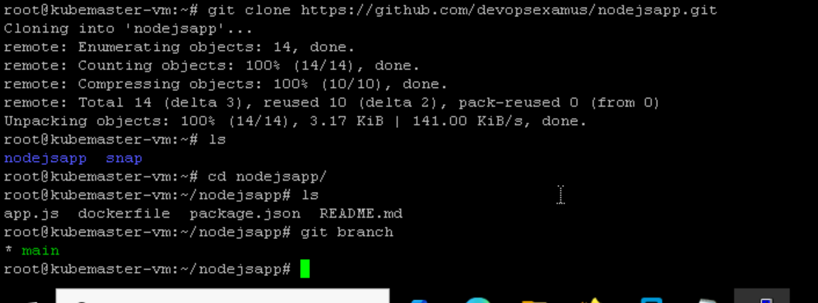

1. **Created a pipeline name node-js**

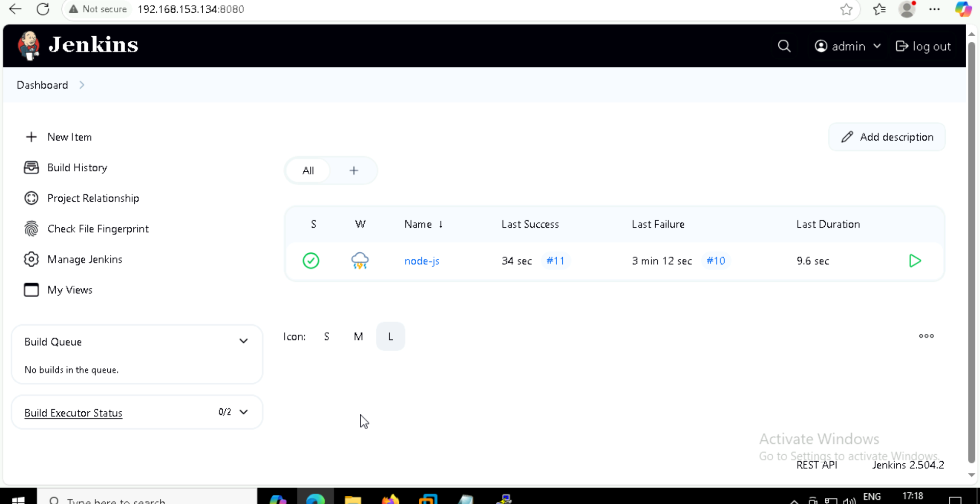

1. **Builded image in Kubernetes ,checking is it working or not**

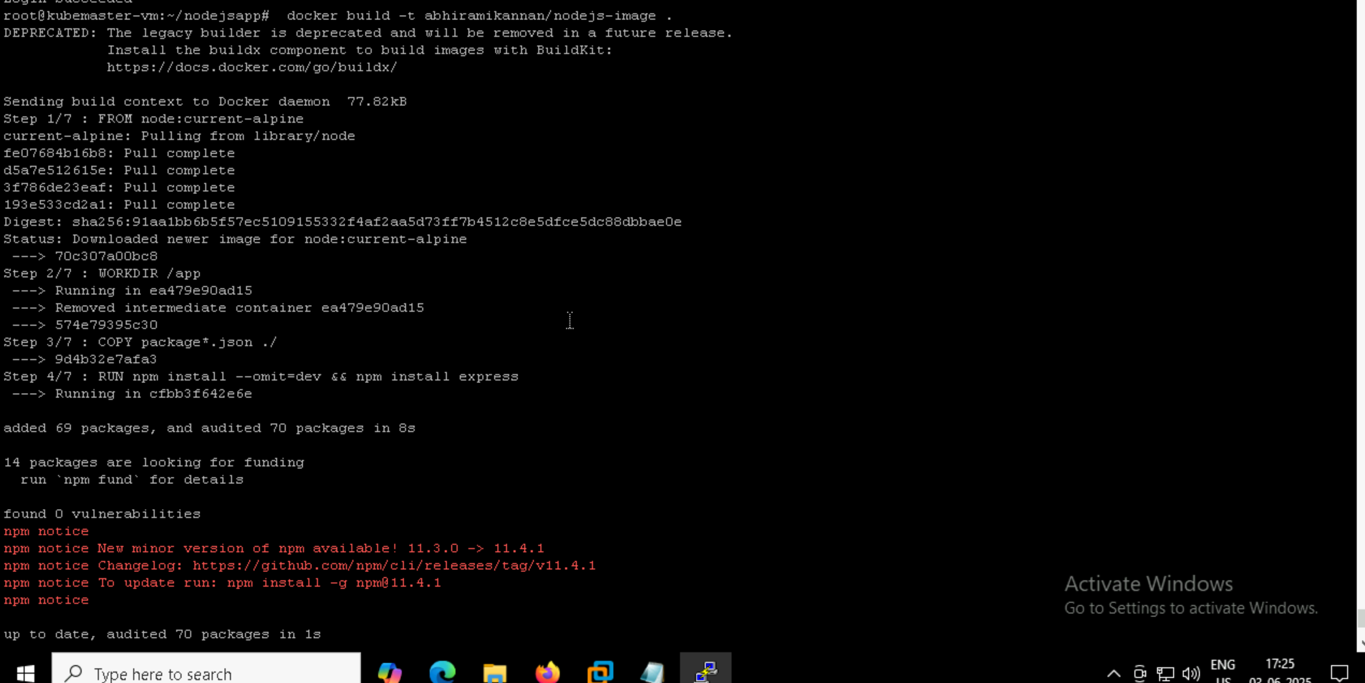

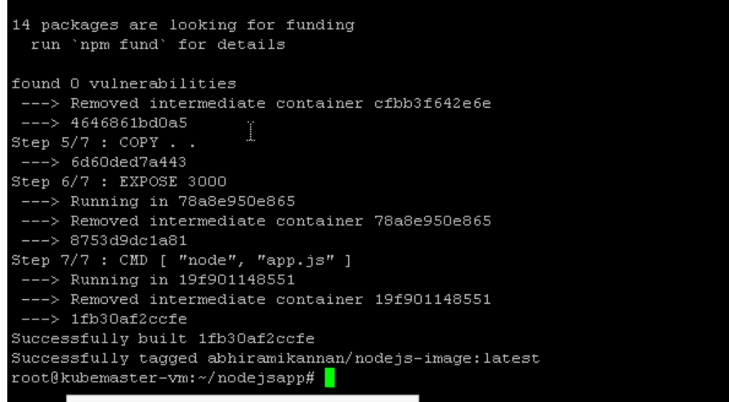

1. **Builded image in pipeline and pushed**

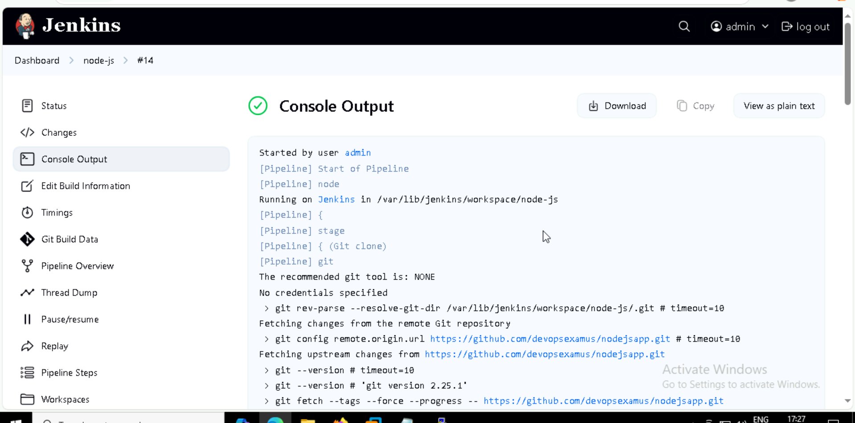

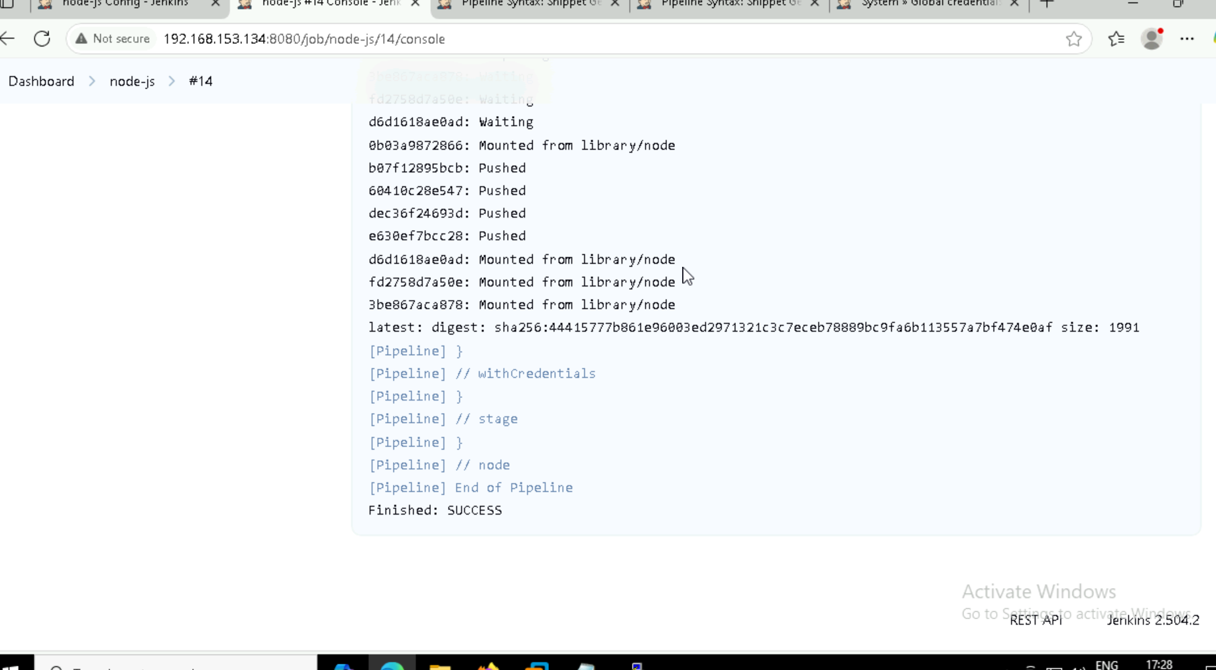

1. **Done the npm install and npm test (tested)**

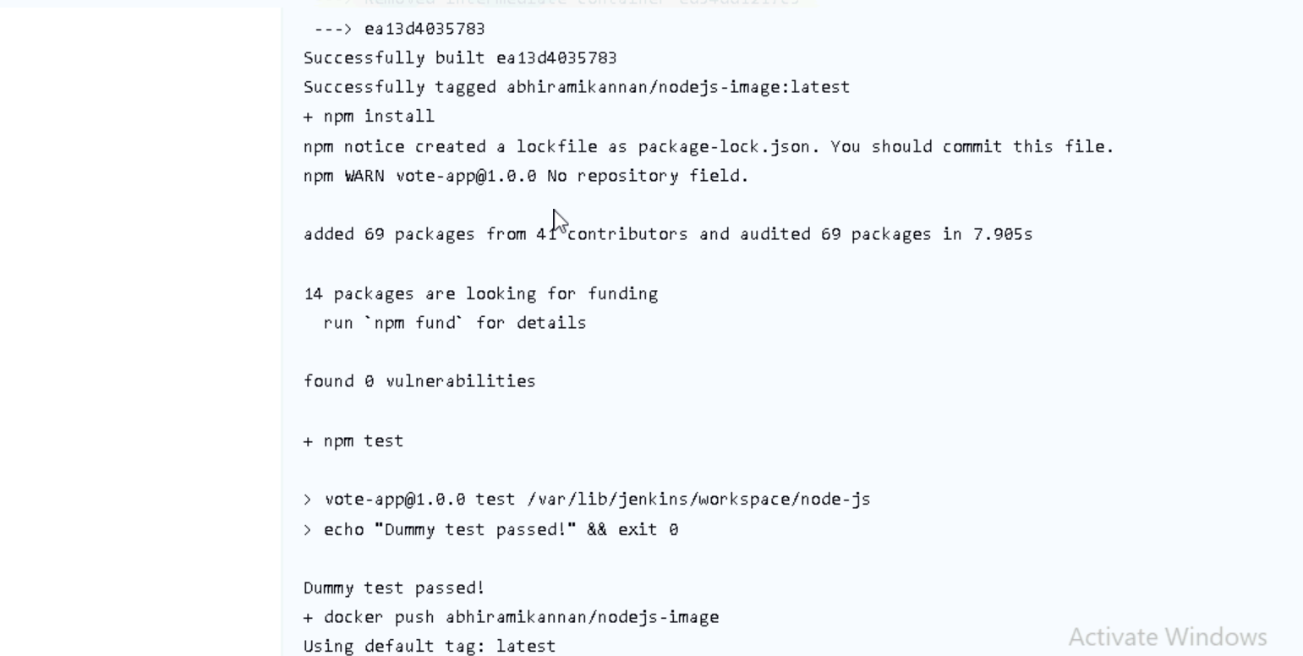

1. **docker search abhiramikannan**



Here I got the image that I pushed

1. **I checked my image is working properly or not by creating a pod named pod**

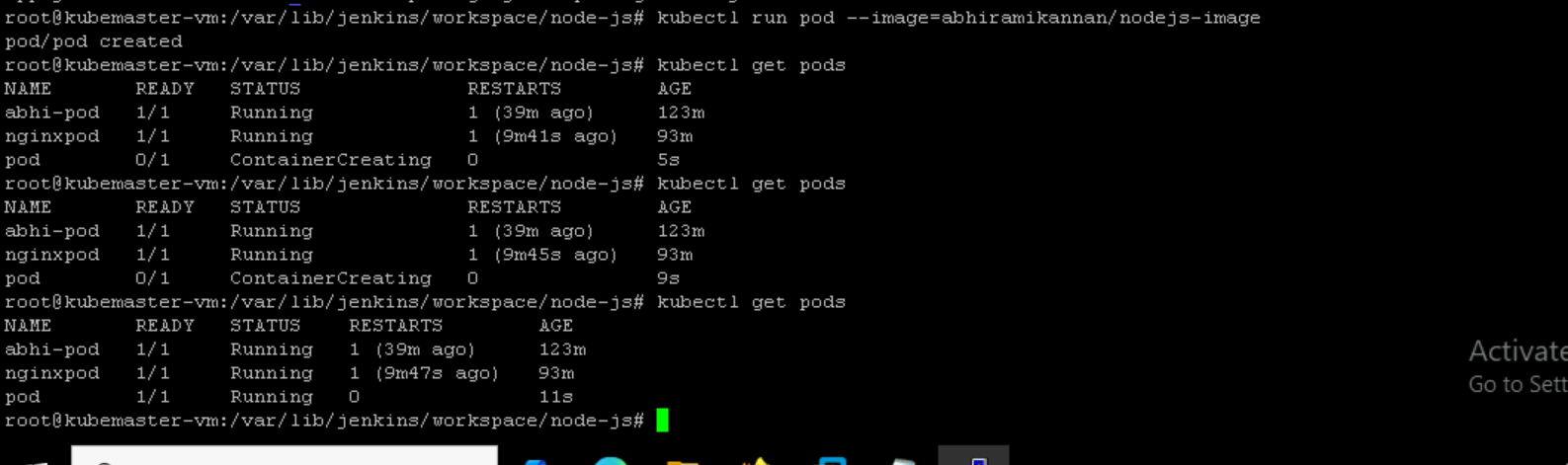

1. **Created a yaml file for deployment inside my workspace** 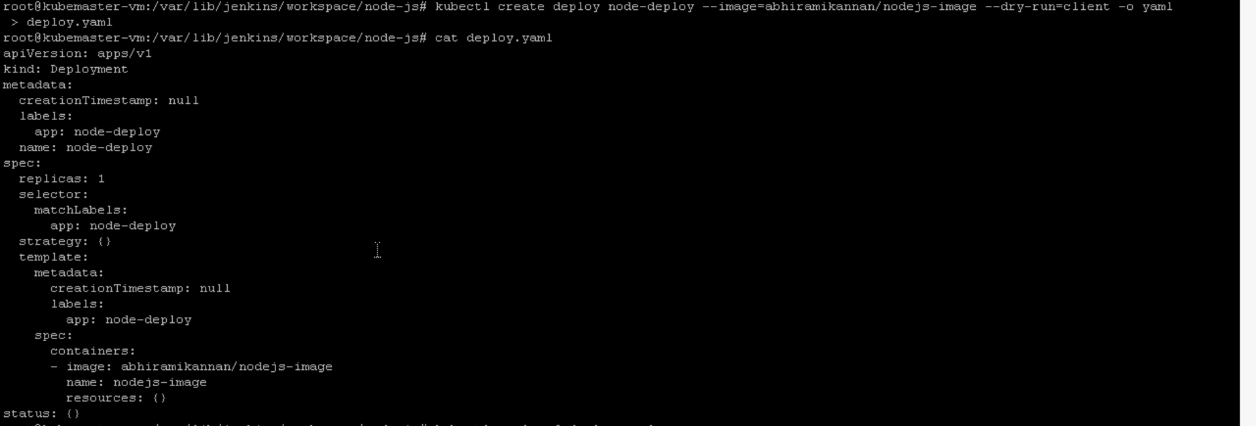

**Command:**

Kubectl create deploy node-deploy –image=abhiramikannan/nodejs-image dry-run=client -o yaml > deploy.yaml

1. **I created a yaml file for service nodeport inside my workspace**
   1. I created the yaml file using a command
   2. Kubectl expose deploy node-deploy –image=abhiramikannan/nodejs-image –port=80 –targetport=3000 --type=NodePort –dry-run=client -o yaml >service.yaml
2. **Cat service.yaml**

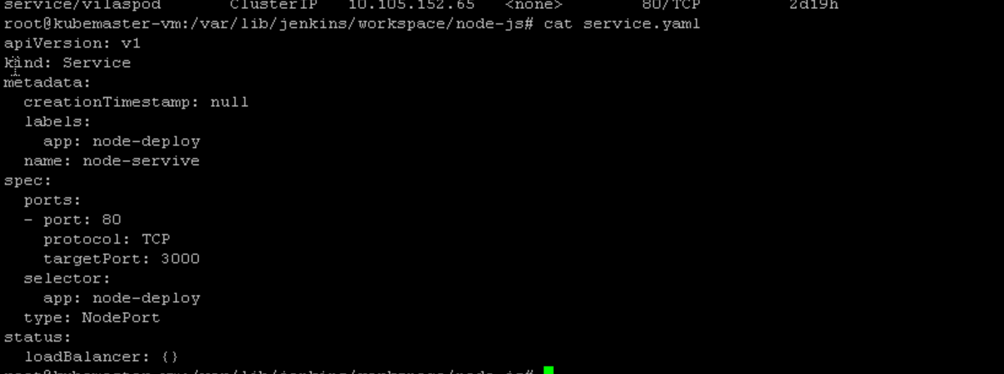

1. **Through Jenkins I created the deployment and service**

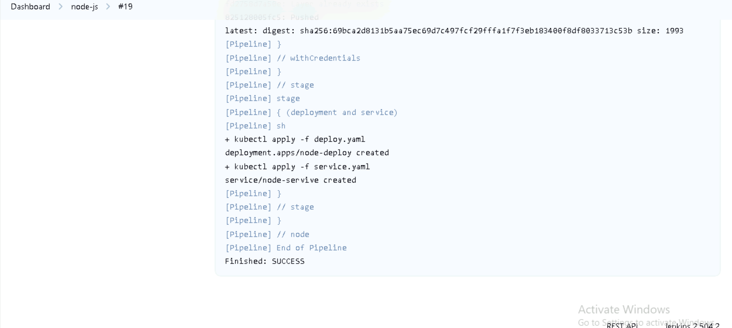

1. **Pipeline script:**

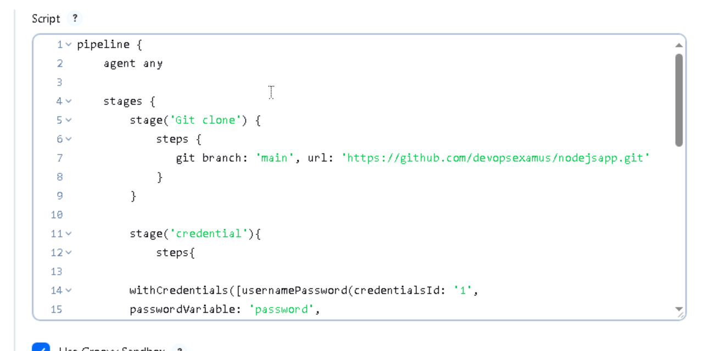

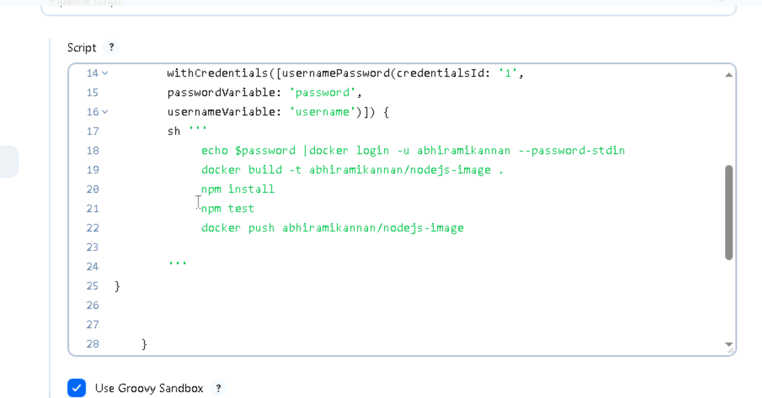

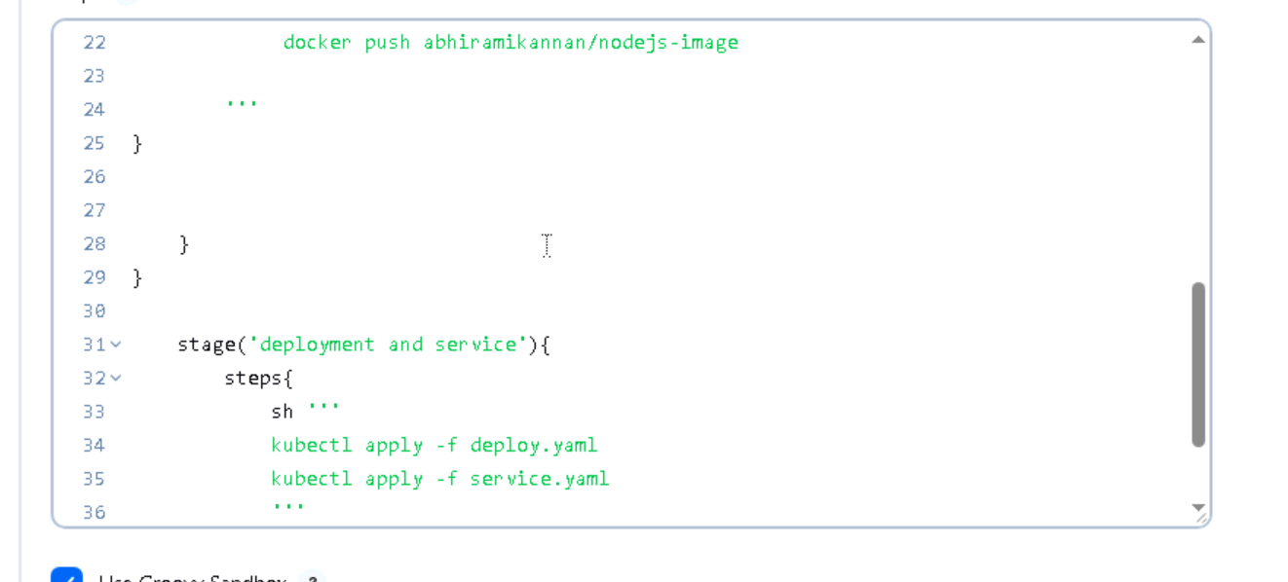

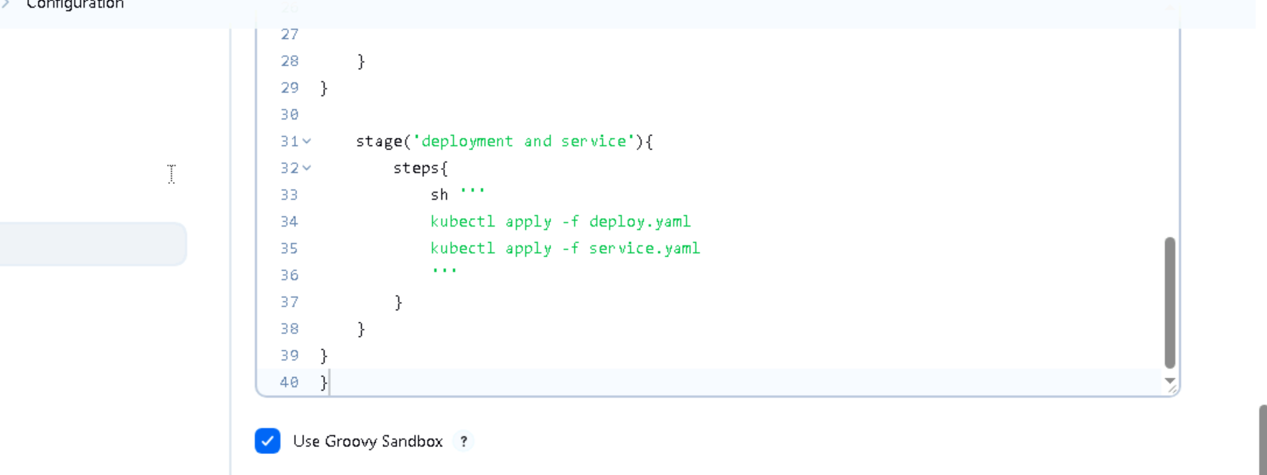

1. Checked the service and deployment created in workspace or not

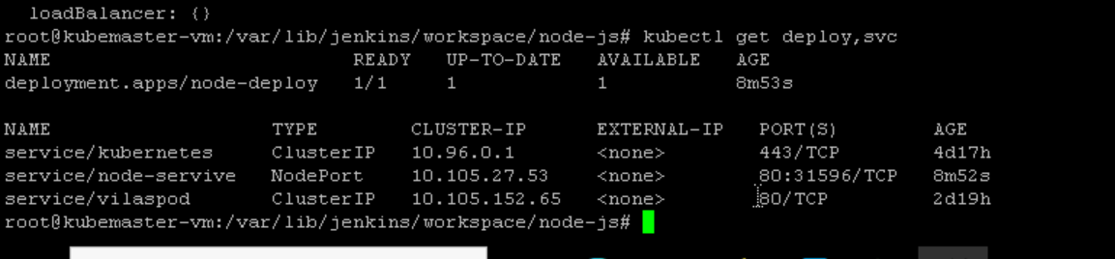

Name of deployment: node-deploy

Name of service : node-service

1. **Tried curl =worked : curl 10.105.27.53:80**

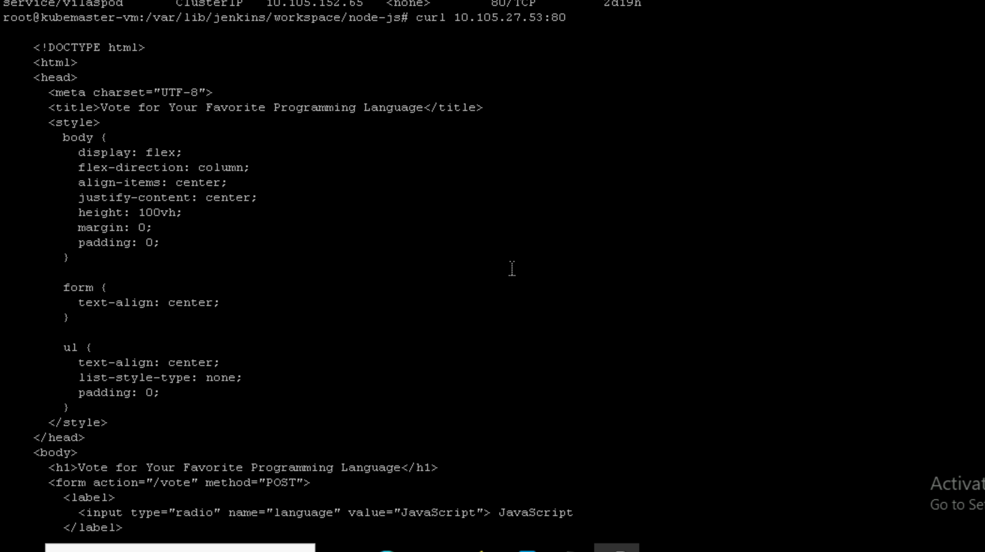

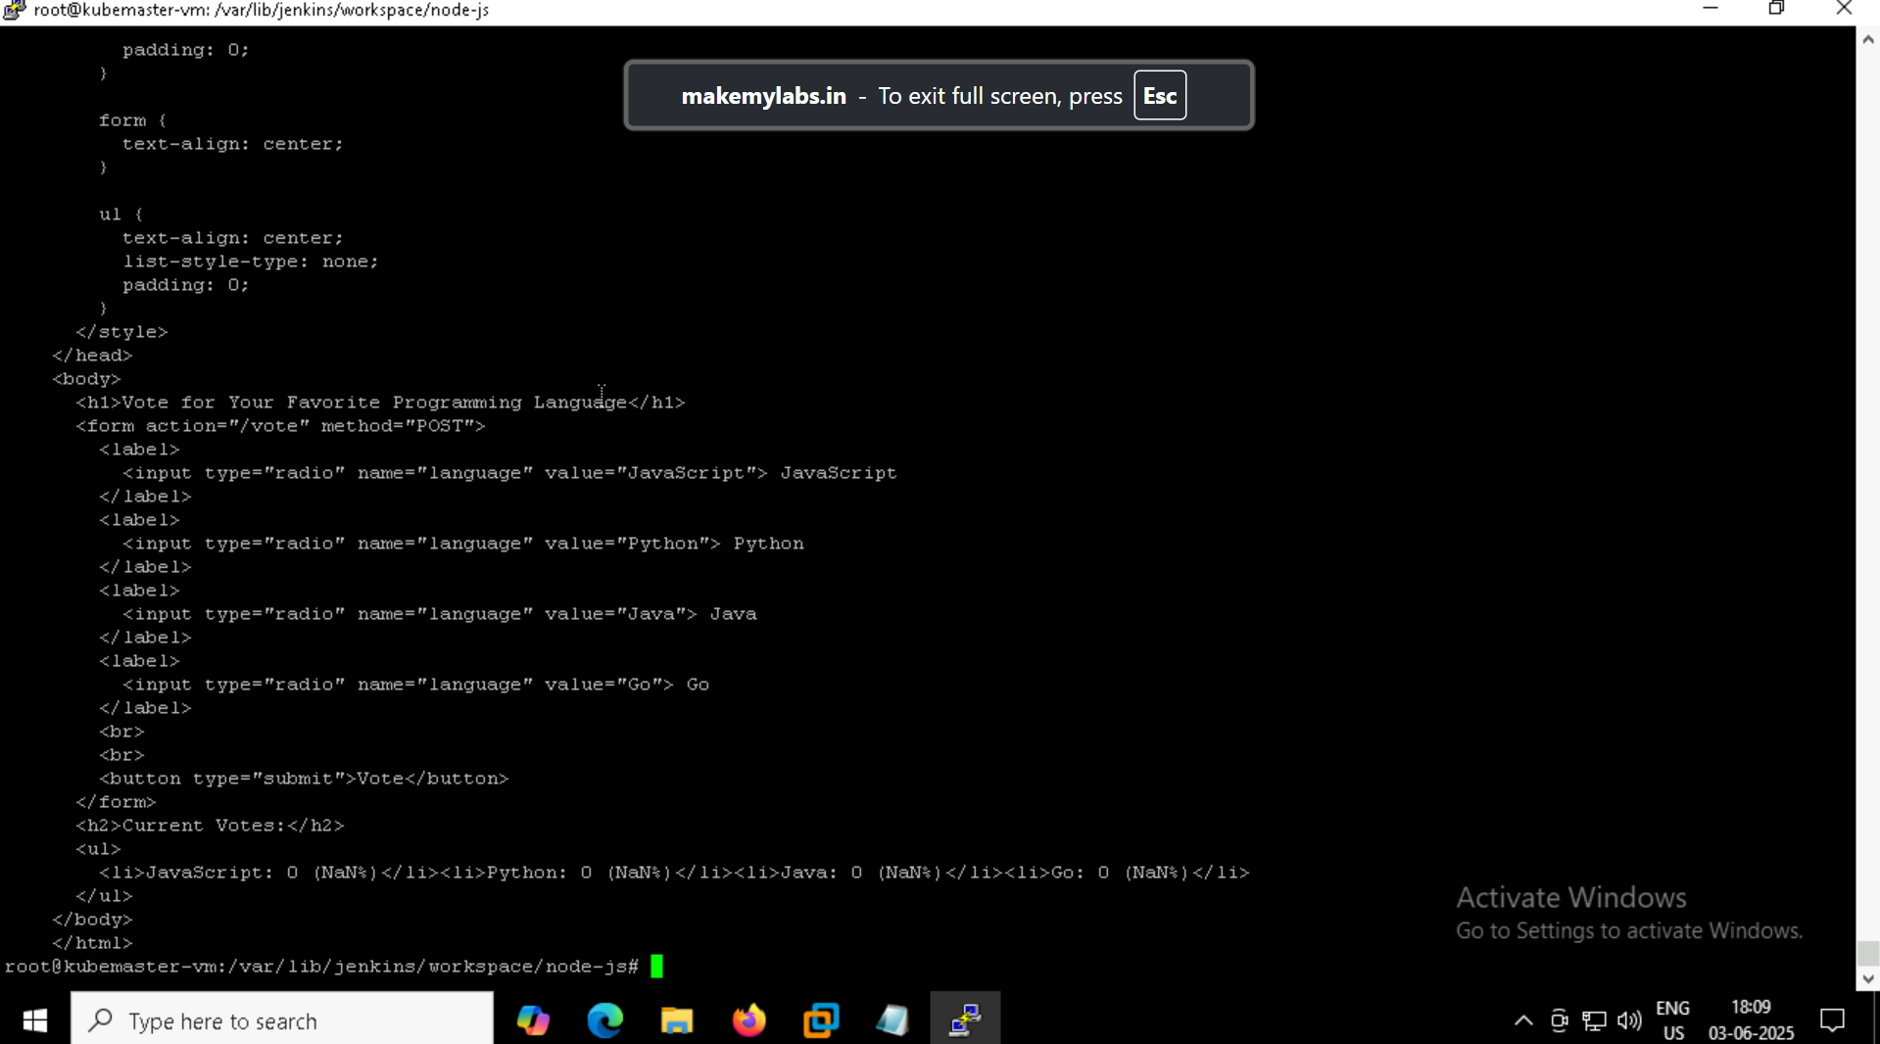

1. So this is the cicd and working pipeline script and documentation for the question